National University of Computer and Emerging Sciences



Laboratory Manuals
for
Computer Networks - Lab

(CL -3001)

Course Instructor | Ms. Umme Ammarah
Lab Instructor | Ms. Sarah Abid Khan
Section | BDS-8A
Semester | Spring 2025

Department of Computer Science FAST-NU, Lahore, Pakistan

Lab Manual 12

Objective:
- OSPF in Cisco Packet Tracer

Question 1:

Implement the following topology and use OSPF protocol.

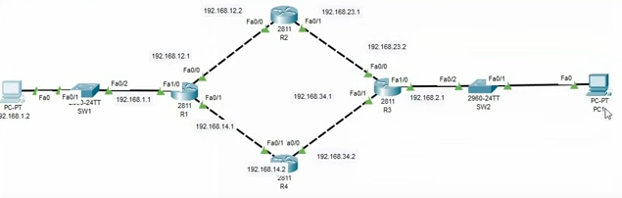

Question 2:

Implement the following topology and use OSPF protocol.

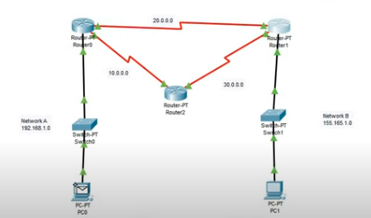

Helping Videos:

https://www.youtube.com/watch?v=2y2IvslS51E

https://www.youtube.com/watch?v=3SHtTW3EFuc

